**ST. JANAN LUWUM SECONDARY SCHOOL KABALAGALA**

**S.3 END OF TERM ONE GEOGRAPHY EXAMINATION.**

TIME: 2HOURS.

**INSTRUCTIONS**

**This paper has 3 items.**

**All items are compulsory.**

***Item 1***

In the recent times our communities are so much concerned about the way we use our environment. In the rural areas the rate of environmental degradation is at an increasing rate where the forests, swamps, rivers ,soil and lakes all are highly polluted. This is threatening the existence and survival of all the living organisms including man.

**Support materials.**

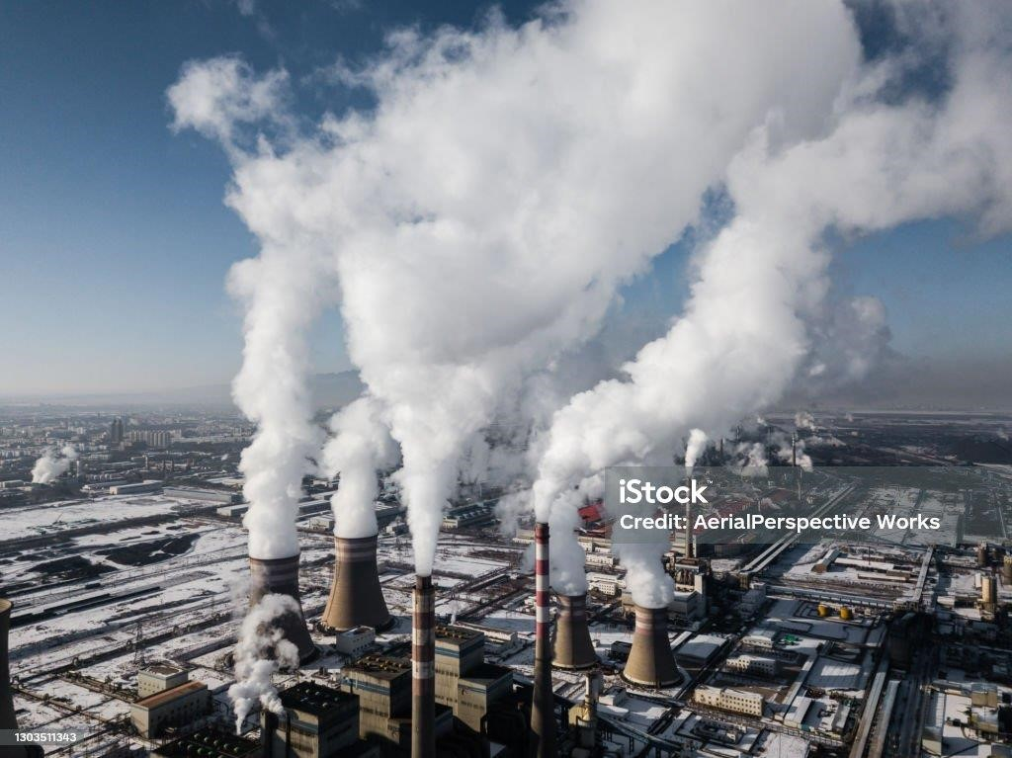 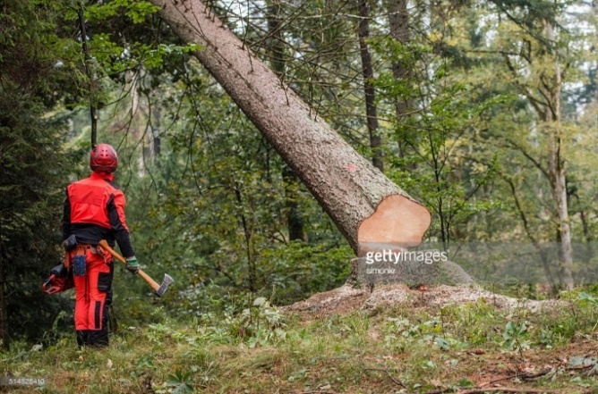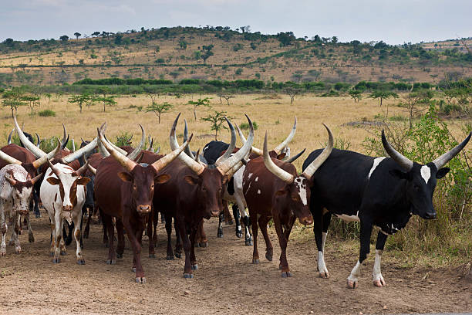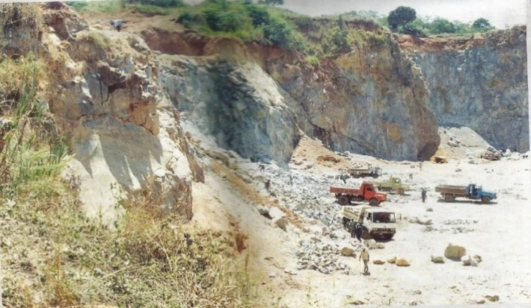

Fig. 1

**Task**: you are part of the community where some or all of the activities seen in the support material are practiced. The environmental committee in your area has convened a local meeting in which you will make a presentation. Prepare a **written speech** which you will read before the gathering to assist the community in your home area to reduce these activities such that the future generations find it.(20scores)

Item2

The earth will stop moving. This was one of the News published by one of the media group during the debate with the National Geographical societ in their annual discussions. The possibility of it is neither having a scientific explanation or logical doubt. The debating club in your school has organised a prsentation on one of the weekly assembly in your school. On the assembly all the school administrators are expected to attend.

**Support material**

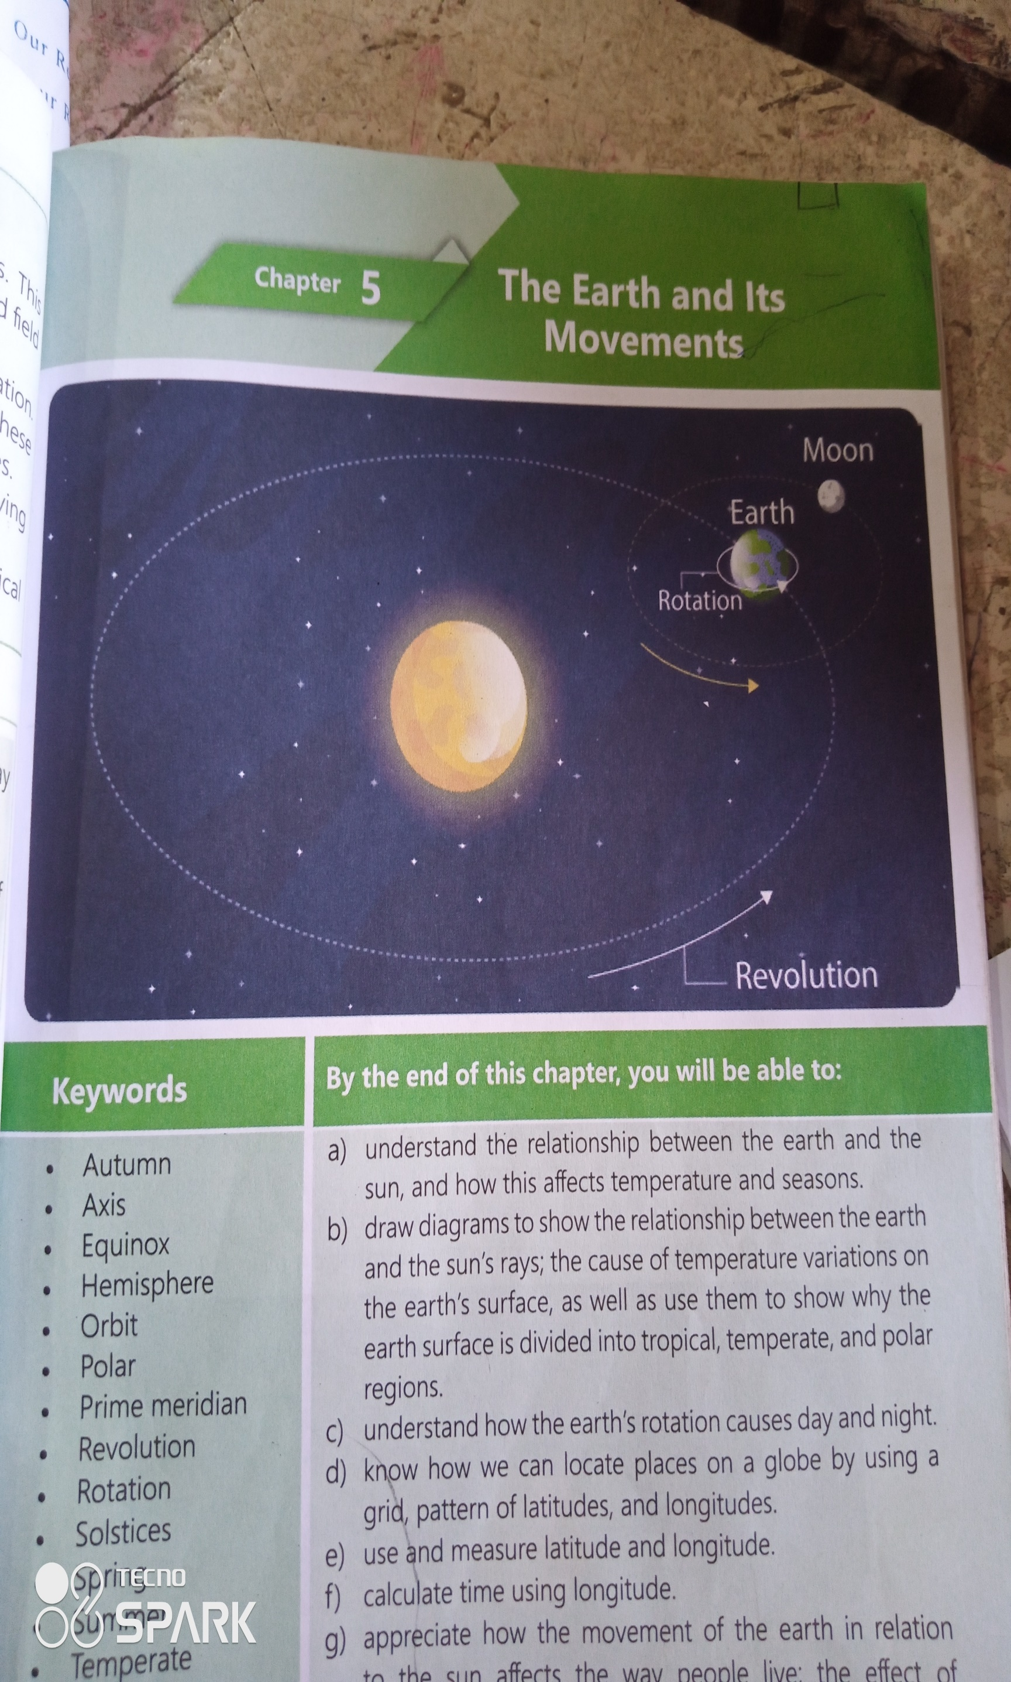

SUN

Fig.2

**Task:** Assumuming you are the president of the Geography club in your school, prepare a **presentation** you will read on assembly explaining the these movements, effects and what can happen to the people’s way of life if at all the earth can stop moving. (15scores)

**Item 3**

Study the text bellow and fig.3 provided and use them to answer this item**.**

In the middle of march this year an un-usual thing happened. Almost the whole month was hot. Heat waves wrere the order of the day to the extent that even the water supply system got affected leading to scarcity of water for use. In other parts of the world like Somalia livestock have died, people have fled to exile due to famine. The rains have become so unreliable to the extent that the rains can come in months which were known to be dry and fail to come when they are expected. Something wrong happened and something urgent need to be done and soon.

**Support materials**.

 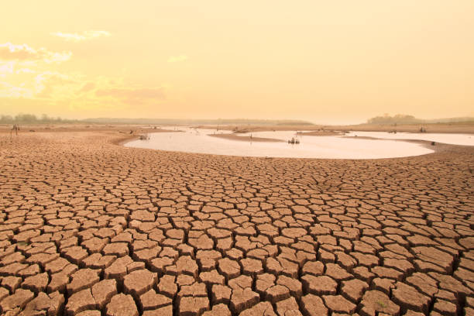

**Fig 3**

Task. As a geography student, explain what the situation in the text and support material provided is, the causes and what can be done to overcome that situation. (15scores